E-VOTING SYSTEM FOR BLIND AND VISUALLY IMPAIRED VOTERS
An Accessible, Audio-Guided Web Application for Inclusive Elections



Submitted By
Inayat Ullah (S2023065045) — Backend Developer
Salar Khan (S2023065088) — AI Integration
Uzair Shakir (S2023065101) — Frontend Developer

Session
Session 2023–2027 · Semester 7 · FYP-I

Project Supervisor
Dr. Amber Sultan

Department of Software Engineering
School of Systems and Technology
University of Management and Technology
C-II Johar Town, Lahore, Pakistan

Final Approval
This is to certify that the Final Year Project titled “E-Voting System for Blind and Visually Impaired Voters”, submitted by the students named below, has been examined and is approved for the award of the degree of Bachelor of Science in Software Engineering.
Project Title: E-Voting System for Blind and Visually Impaired Voters
Undertaken by: Inayat Ullah, Salar Khan, Uzair Shakir
Supervised by: Dr. Amber Sultan
Head of Department ______________________________
Department of Software Engineering, University of Management and Technology, Lahore
Program Director (Final Year Projects) ______________________________
Department of Software Engineering, University of Management and Technology, Lahore
Supervisor ______________________________
Department of Software Engineering, University of Management and Technology, Lahore
Co-Supervisor (if any) ______________________________
Department of Software Engineering, University of Management and Technology, Lahore
Documentation Evaluator ______________________________
Department of Software Engineering, University of Management and Technology, Lahore

Acknowledgment
We are deeply grateful to our supervisor, Dr. Amber Sultan, for her continuous guidance, encouragement and valuable feedback throughout this project. We also thank the Department of Software Engineering at the University of Management and Technology for providing the resources and environment that made this work possible. Finally, we acknowledge the persons with disabilities and the disability-rights organisations whose lived experiences motivated and shaped this project.

Declaration
We hereby declare that this Final Year Project report and the system it describes are the result of our own work, except where explicit reference is made to the work of others. This document has been prepared in accordance with the FYP Documentation Template and has not been submitted, in whole or in part, for any other degree or qualification.
The accompanying repository contains the source code, and this PDF together with the user manual and installation guide will be provided on submission.
FYP Supervisor Name: ______________________________
Signature: __________________ Date: __________________

Abstract
Voting is a fundamental democratic right, yet persons with disabilities in Pakistan—and blind and visually impaired citizens in particular—continue to face significant barriers to exercising it independently and in secret. Traditional polling relies on printed ballots and physical polling stations, forcing visually impaired voters to depend on assistants, which compromises both their privacy and the dignity of an independent vote.
This project proposes an accessible, audio-guided web-based e-voting system designed primarily for blind and visually impaired voters. Built with the Django framework and an HTML/CSS/Bootstrap front end, the system pairs WCAG 2.1 accessibility practices—screen-reader support, full keyboard operation, high-contrast and enlarged text—with AI-assisted features such as text-to-speech ballot reading and a voice-guided assistant. Voters are verified through their CNIC, cast exactly one encrypted vote, and never receive any record of whom they voted for, preserving vote secrecy. Election administrators (the Government / Election Commission) manage elections and candidates and can view only aggregate results per party per constituency, and only after an election closes.
This report documents the first phase of the project (FYP-I): the problem analysis, domain and literature review, complete requirements expressed as an Agile product backlog, the user-interface and workflow design, and the planning and artifacts of the first development sprint.

Revision Chart
This chart records the revision history of this document.
Version | Primary Author(s) | Description of Version | Date
Draft | Project Team | Initial draft for supervisor review | 17-6-2026
Preliminary | Project Team | Second draft incorporating review comments | TBD
Final | Project Team | First complete draft placed under change control | TBD
Table 1: Document revision history

Table of Contents
Abstract 4
Definitions and Acronyms 8
List of Figures 9
List of Tables 10
1. Introduction 11
1.1 Problem Statement 11
1.2 Objectives 11
1.3 Scope of the Project 11
1.4 Significance of the Project 12
1.5 Artificial Intelligence Features 12
1.6 Project Deliverables 12
1.7 Proposed Methodology 12
2. Domain Analysis 13
2.1 Customer 13
2.2 Stakeholders 13
2.3 Affected Groups with Social or Economic Impact 13
2.4 Dependencies / External Systems 13
2.5 Related Projects with Feature Comparison 14
2.5.1 Related Projects 14
2.5.2 Feature Comparison 14
2.6 Literature Review 14
2.7 Context Diagram 15
2.8 Data Flow Diagram (Level 0) 15
2.9 References 16
3. Requirements Analysis 18
3.1 List of Actors 18
3.2 Product Backlog 18
3.2.1 Representative Task Breakdown (Sprint 1 items) 20
3.3 Figma UI/UX Designs 20
4. Project Planning and Execution using Sprints 25
4.1 Jira 25
4.2 Slack 25
4.3 GitHub Repository 25
4.4 Sprint 1 25
4.4.1 Sprint 1 Planning Meeting Minutes 25
4.4.2 Sprint 1 Backlog 27
4.4.3 Sprint 1 Design Class Diagram 27
4.4.4 Sprint 1 Sequence Diagram 28
4.4.5 Sprint 1 Decision Table 29
4.4.6 Sprint 1 Extended Test Cases 29
4.4.7 Sprint 1 Review Meeting 30
4.4.8 Sprint 1 Retrospective Meeting 30
5. System Architecture 31
6. Implementation Details 31
7. Project Monitoring, Control and Traceability 31
8. Results / Output / Statistics 31
9. Conclusion 31
10. Future Work 31
11. Bibliography 31
12. Appendix 31

Definitions and Acronyms
Term / Acronym | Definition
PWD | Person With Disability.
Blind / VI | Blind or visually impaired user; the primary user of this system.
TTS | Text-to-Speech; converts on-screen text into spoken audio.
Screen Reader | Assistive software that narrates UI content (e.g., NVDA, TalkBack).
WCAG 2.1 | Web Content Accessibility Guidelines 2.1 by the W3C (POUR principles).
ARIA | Accessible Rich Internet Applications; markup that exposes UI semantics to assistive tech.
CNIC | Computerized National Identity Card (Pakistan).
NADRA | National Database and Registration Authority (identity verification).
ECP | Election Commission of Pakistan.
Halqa | An electoral constituency / division.
OTP | One-Time Password.
Epic / User Story | Agile backlog items: a large body of work, and a user-centred requirement.
Story Point | Relative measure of effort/complexity (Fibonacci scale).
Sprint | A fixed, short iteration (one week in this project).
Table 2: Definitions and acronyms

List of Figures
Figure 1: Context diagram of the E-Voting System
Figure 2: Level-0 Data Flow Diagram of the E-Voting System
Figure 3: Voter interaction workflow (system flow)
Figure 4: Voter login — CNIC + OTP with audio guidance and voice input
Figure 5: Ballot / cast vote — large high-contrast candidate cards with read-aloud and visible focus
Figure 6: Vote confirmation — audio read-back before the vote is finalised
Figure 7: Admin dashboard — manage elections, candidates and voters (Government / ECP)
Figure 8: Results — aggregate totals per party, shown only after the election closes
Figure 9: Sprint 1 design class diagram
Figure 10: Sprint 1 sequence diagram — Cast Vote

List of Tables
Table 1: Document revision history
Table 2: Definitions and acronyms
Table 3: Project stakeholders
Table 4: External systems and dependencies
Table 5: Feature comparison with related products
Table 6: System actors
Table 7: Product backlog (epics, user stories, priority and estimates)
Table 8: Sprint 1 planning — meeting overview
Table 9: Sprint 1 committed backlog items
Table 10: Sprint 1 task distribution
Table 11: Sprint 1 timeline
Table 12: Sprint 1 risks and mitigations
Table 13: Sprint 1 backlog (tasks and status)
Table 14: Decision table for vote-casting eligibility
Table 15: Sprint 1 extended test cases
Table 16: Sprint 1 review meeting
Table 17: Sprint 1 retrospective

1. Introduction
This project, the E-Voting System for Blind and Visually Impaired Voters, is an accessible web application that enables blind and visually impaired citizens to cast their votes independently, privately and securely. It combines established web-accessibility practice (WCAG 2.1) with AI-assisted features—text-to-speech ballot reading and a voice-guided assistant—so that a voter who cannot see the screen can complete the entire voting process by listening and by using the keyboard or voice.

1.1 Problem Statement
Voting is a fundamental democratic right, but blind and visually impaired citizens in Pakistan cannot exercise it independently. Standard elections rely on printed ballot papers and in-person polling stations. A voter who cannot see the ballot must rely on a polling agent or family member to mark it on their behalf, which removes the secrecy of the ballot and undermines the dignity of an independent vote [6][9]. Studies of disability inclusion in Pakistani elections report that barriers begin well before polling day—obtaining a CNIC, registering on the electoral rolls, transport to the polling booth, and inaccessible polling premises—and that special provisions such as tactile devices or large-print ballots for the visually impaired are largely unavailable in practice [6]. Field reporting from the 2024 general election similarly described remote and multi-storey polling stations as major obstacles for voters with disabilities [7]. The core problem this project addresses is therefore the absence of an accessible, independent and secret way for blind and visually impaired citizens to vote.

1.2 Objectives
- To design and build a web-based e-voting system that a blind or visually impaired voter can operate entirely through audio output and keyboard (or voice) input.
- To apply WCAG 2.1 accessibility principles—perceivable, operable, understandable and robust—throughout the interface.
- To verify voter identity through CNIC-based authentication while preserving the secrecy of every vote.
- To enforce a strict one-person-one-vote rule and to encrypt each cast vote at rest.
- To provide election administrators with secure management tools and with aggregate-only results that are released only after an election closes.
- To integrate AI-assisted accessibility: text-to-speech ballot reading and a voice-guided assistant that supports the voter step by step.

1.3 Scope of the Project
The system focuses on blind and visually impaired voters as its primary users. Within scope: voter registration and CNIC-based verification; an accessible, audio-guided ballot; one encrypted vote per voter per election; administrator tools for managing elections, candidates and voters; aggregate results released after close; and an audit log that never records vote choices. The accessibility design (high contrast, enlarged text, full keyboard operation) also benefits low-vision and some motor-impaired users, but these groups are not the primary focus.
Out of scope for this project (recorded as future work): sign-language recognition and lip-reading for deaf users, biometric/facial-recognition login, and nationwide deployment at the scale of a real general election. These are discussed in the project’s Future Work.

1.4 Significance of the Project
By giving blind and visually impaired citizens the ability to vote on their own, the project advances electoral inclusion and the secrecy and dignity of the vote—commitments that Pakistan has repeatedly endorsed but only partially implemented [6]. Research on accessible voting consistently finds that visually impaired voters strongly prefer audio-based interfaces and value the independence they provide [3][2]. A working, locally-relevant prototype demonstrates that such inclusion is technically achievable with mainstream web technologies, and provides a foundation that the Election Commission or civil-society organisations could extend.

1.5 Artificial Intelligence Features
The system uses AI to make the experience usable without sight rather than as a standalone novelty:
- Text-to-Speech (TTS) ballot reading. Candidate names, parties, instructions and confirmations are spoken aloud, so a blind voter perceives the ballot entirely through audio.
- Voice-guided assistant / chatbot. A conversational assistant guides the voter through each step and answers help requests using voice prompts.
- Voice input (assistive). As an optional accessibility aid, the voter can speak their CNIC and selections, with the system reading the captured value back for confirmation.
Sign-language recognition, lip-reading and facial-recognition login were considered but deliberately deprioritised: they are not required for a selection-based voting task and introduce significant accessibility friction for blind users. They are recorded as future work.

1.6 Project Deliverables
- A working accessible e-voting web application (Django + HTML/CSS/Bootstrap).
- Source code under version control (GitHub) with installation and user guides.
- A complete Agile product backlog (Jira) of epics, user stories, tasks, priorities and estimates.
- UI/UX design and workflow (rebuilt in Figma from the wireframes in this report).
- Sprint plans, sprint backlogs and meeting records (planning, review, retrospective).
- This documentation, completed through Chapter 4 for FYP-I.

1.7 Proposed Methodology
The project follows an Agile Scrum methodology. Work is organised as a prioritised product backlog and delivered in fixed one-week sprints, each ending with a potentially shippable increment. Every sprint includes planning, daily coordination, a review and a retrospective. The team uses Jira for the backlog and sprint board, Slack for communication, GitHub for version control, GitHub Copilot for AI-assisted coding, and Figma for interface design. The MoSCoW technique (Must / Should / Could / Won’t) is used to prioritise backlog items, and effort is estimated in story points (Fibonacci) together with indicative hours. Chapter 4 documents how this methodology is applied in Sprint 1.

2. Domain Analysis
This chapter analyses the domain of accessible electronic voting: who the system serves, who is affected, what external systems it depends on, how it compares with related work, and what the academic and practitioner literature recommends. It closes with the context and data-flow models of the proposed system.

2.1 Customer
The customer is the Government of Pakistan, represented by the Election Commission of Pakistan (ECP), which is responsible for conducting inclusive and accessible elections. The ECP has a dedicated Gender and Social Inclusion Wing and has committed—through national declarations and with partners such as IFES and STEP—to improving the participation of persons with disabilities [6]. The system is designed to be operated by such an electoral authority.

2.2 Stakeholders
Stakeholder | Interest in the system
Blind / visually impaired voters | Primary users; need to vote independently, privately and with dignity.
Government / ECP (Admin) | Owns and operates the system; manages elections, candidates and voters; views aggregate results.
Candidates / political parties | Appear on the ballot; require a fair and tamper-proof count.
NADRA | Provides CNIC identity verification used during registration/login.
Disability-rights organisations (e.g., STEP) | Advocate for and validate accessibility; potential adopters.
Project team & supervisor | Design, build and evaluate the system within FYP-I/II.
Table 3: Project stakeholders

2.3 Affected Groups with Social or Economic Impact
Beyond direct users, several groups are affected. Visually impaired and other disabled citizens gain a channel to participate in democracy without depending on an assistant, which has clear social value in autonomy and inclusion. Election staff and polling agents are relieved of the sensitive task of marking ballots on a voter’s behalf, reducing the risk of coercion or error. Society and the State benefit from broader, more representative participation; estimates place the number of persons with disabilities in Pakistan in the millions, a substantial share of whom are effectively excluded from voting today [7]. Economically, a digital channel can reduce the per-voter cost of providing physical accommodations at every polling station.

2.4 Dependencies / External Systems
External system | Dependency
NADRA CNIC verification | Confirms the identity and validity of a voter’s CNIC during registration/login (mocked in development).
SMS / OTP gateway | Delivers one-time passwords for secure login.
Browser Speech APIs / TTS engine | Provide text-to-speech output and optional speech input.
Assistive technologies (screen readers) | NVDA, VoiceOver, TalkBack consume the ARIA semantics the system exposes.
Cloud hosting platform | Hosts the application and database for availability during elections.
Table 4: External systems and dependencies

2.5 Related Projects with Feature Comparison

2.5.1 Related Projects
Several systems and studies address electronic or accessible voting. Voatz is a mobile voting application piloted in some United States elections, but it is general-purpose and has drawn scrutiny over security. Conventional accessible voting machines reviewed by the American Foundation for the Blind provide spoken ballots and are a major improvement over assisted paper voting, though they remain polling-station devices rather than remote web systems [9]. In research, multimodal e-voting prototypes for blind users (for example, the system evaluated at the Alabama Institute for the Deaf and Blind) report that audio-based, user-centred designs are easy to use and trusted by visually impaired participants [2], and recent work proposes AI-assisted voting interfaces specifically to raise turnout among the visually impaired [1].

2.5.2 Feature Comparison
Feature | Voatz | Accessible voting machines | This project
Remote / web-based | Yes (mobile) | No (on-site) | Yes (web)
Designed for blind users | Partial | Yes (audio) | Yes (primary focus)
TTS + screen-reader + keyboard | Limited | Audio only | Full (WCAG 2.1)
Voice-guided assistant | No | No | Yes
Aggregate-only, post-close results | Varies | N/A | Yes
Localised to Pakistan / CNIC | No | No | Yes
Table 5: Feature comparison with related products

2.6 Literature Review
The literature converges on a few clear findings that shape this project. First, accessibility is best understood through the W3C’s WCAG 2.1, which organises web accessibility under four principles—Perceivable, Operable, Understandable and Robust (POUR)—and underpins accessibility law and practice internationally [5]. For a blind user the most relevant requirements are text alternatives, full keyboard operability and robust markup that assistive technologies can interpret.
Second, surveys of blind voters show a strong preference for audio-based voting. A questionnaire study of 180 legally blind voters found that respondents preferred audio voting systems over alternatives such as Braille [3], which directly justifies this project’s audio-first design rather than a Braille- or tactile-centred approach. Third, controlled studies of multimodal e-voting for the blind report high usability and trust when the interface is designed around the user’s needs, while also cautioning that some input methods (for example, mouse-driven virtual keyboards) actively degrade performance for users who cannot see the screen [2][4]. These results motivate the project’s emphasis on keyboard and voice input with continuous audio feedback, and on reading each selection back to the voter before submission.
Fourth, the practitioner literature on accessible voting machines confirms that spoken ballots, over-vote prevention and explicit review/confirmation steps are essential safeguards, and that adjustable contrast and text size matter for low-vision users [9]. Finally, the Pakistan-specific literature documents persistent, well-known barriers—identity registration, transport, and inaccessible polling stations—and notes that although the Elections Act 2017 extended postal voting to persons with disabilities, on-the-ground accommodations remain limited [6][7][8]. Taken together, the literature supports an audio-first, WCAG-aligned, remotely accessible voting system localised to the Pakistani context, which is precisely the gap this project targets.

2.7 Context Diagram
The context diagram models the system as a single process interacting with three external entities—the blind voter, the election administrator (Government/ECP) and NADRA—together with the data that flows between them.
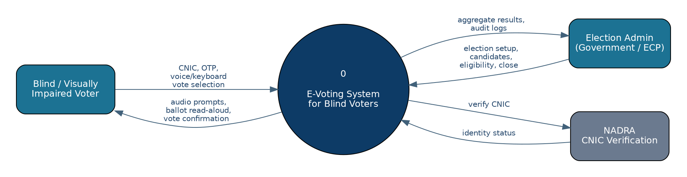
Figure 1: Context diagram of the E-Voting System

2.8 Data Flow Diagram (Level 0)
The Level-0 DFD decomposes the system into four core processes—authenticate and verify the voter, manage elections and candidates, cast a vote with audio support, and tally and report results—operating over four data stores (Voters, Elections & Candidates, Votes, Audit Log). Note that votes flow into the Votes store in encrypted form and that results flow to the admin only as aggregates.
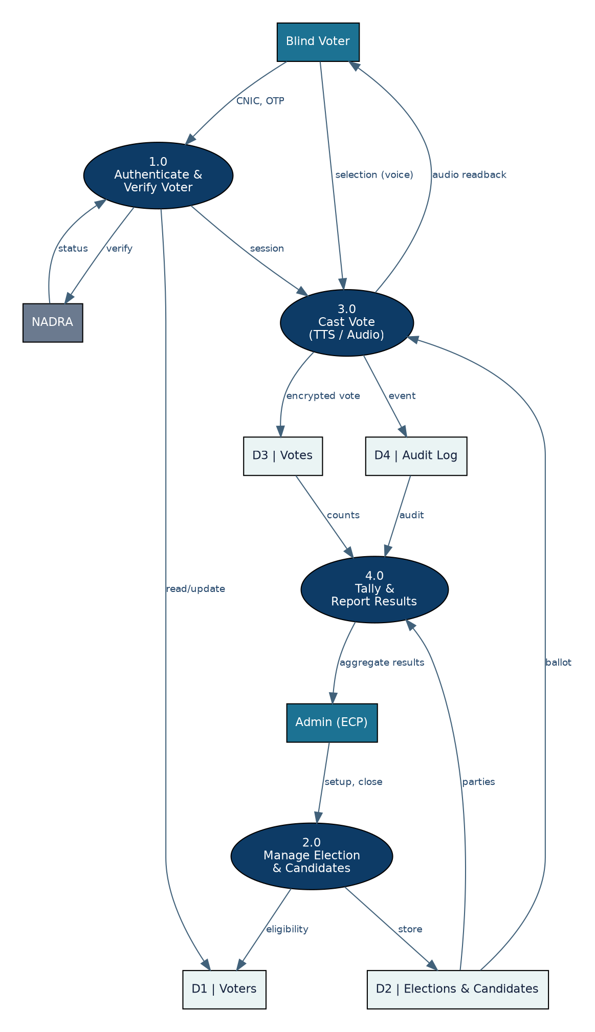
Figure 2: Level-0 Data Flow Diagram of the E-Voting System

2.9 References
[1] C. Antony et al., “AI-Powered Voting System Enhancing Accessibility for Visually Impaired Individuals in Elections,” International Journal of Computer Applications, vol. 186, no. 73, Mar. 2025.
[2] “Universal access in e-voting for the blind,” Universal Access in the Information Society, Springer (study at the Alabama Institute for the Deaf and Blind).
[3] “Accessible Voting Systems for Visual Impairments,” International Journal of u- and e-Service, Science and Technology, 2016 (survey of 180 blind voters).
[4] “Accessibility, efficacy and improvements in voting methodology for visually impaired persons using a web-based electronic ballot system,” Proc. 8th Indian Conf. on HCI, ACM.
[5] W3C, “Web Content Accessibility Guidelines (WCAG) 2.1,” w3.org/TR/WCAG21.
[6] Special Talent Exchange Program (STEP) / IFES, “Inclusion of Persons with Disabilities in the Electoral Processes in Pakistan,” scoping study; ECP Gender and Social Inclusion Wing.
[7] “For differently-abled individuals voting is a burden,” The Express Tribune, 2024.
[8] International IDEA, on the Elections Act 2017 extending postal voting to persons with disabilities.
[9] American Foundation for the Blind, “Cast a Vote by Yourself: A Review of Accessible Voting Machines,” AccessWorld.

3. Requirements Analysis
This chapter presents the system’s actors, the complete product backlog that expresses its requirements in Agile form, and the interface and workflow design.

3.1 List of Actors
Actor | Description
Voter (Blind / VI) | A citizen registered and verified as a disabled (visually impaired) voter. Logs in, hears the ballot, and casts exactly one vote. The primary actor.
Admin (Government / ECP) | Manages elections, candidates and voters; opens and closes elections; views aggregate results and audit logs after close.
NADRA (external) | Verifies the voter’s CNIC during registration/login. Not a logged-in user.
TTS / Audio service (system) | Internal component that speaks page content and reads the ballot.
Table 6: System actors
Note: candidates are entries on the ballot configured by the Admin; they are not user accounts and do not log in. Only the Voter and the Admin authenticate to the system.

3.2 Product Backlog
The product backlog captures all requirements as epics and user stories, prioritised with MoSCoW (Must / Should / Could) and estimated in story points (Fibonacci) and indicative hours. The backlog contains 7 epics and 31 user stories totalling 154 story points (≈ 476 hours). Selected stories are broken down into tasks in Jira; representative tasks are listed in Section 3.2.1. The backlog is maintained in Jira and a CSV export accompanies this submission.
ID | User Story | Priority | Pts | Hrs | Spr
E1 — Voter Identity & Authentication
US-01 | As a voter, I can register with my CNIC so the system knows I am an eligible disabled voter. | Must | 5 | 16 | S1
US-02 | As the system, I verify a CNIC against NADRA so only real citizens can register. | Must | 8 | 24 | S2
US-03 | As a voter, I log in with CNIC + OTP so my account stays secure. | Must | 5 | 16 | S1
US-04 | As the system, I confirm a voter is registered as disabled before allowing a vote. | Must | 3 | 8 | S1
US-05 | As a voter, I can reset my password/OTP with audio guidance if I am locked out. | Should | 3 | 10 | S4
E2 — Accessibility & Audio Experience
US-06 | As a blind voter, every page is read aloud by TTS so I can use the system without sight. | Must | 8 | 24 | S1
US-07 | As a blind voter, I can navigate the whole app by keyboard only. | Must | 5 | 16 | S1
US-08 | As a screen-reader user, all controls expose correct ARIA roles and labels. | Must | 5 | 16 | S2
US-09 | As a low-vision voter, I can switch to high-contrast mode and enlarge text. | Should | 3 | 10 | S3
US-10 | As a blind voter, I can input my CNIC and choices by voice. | Could | 8 | 24 | S5
US-11 | As a voter, an audio confirmation reads my selection back before submission. | Must | 3 | 10 | S2
E3 — Election & Candidate Management
US-12 | As an admin, I can create an election with a title, halqa/division and open/close times. | Must | 5 | 16 | S2
US-13 | As an admin, I can add candidates (name, party, symbol) to an election. | Must | 3 | 12 | S2
US-14 | As an admin, I can register and manage eligible disabled voters. | Must | 5 | 16 | S3
US-15 | As an admin, I can open and close an election so voting happens only in the window. | Must | 3 | 10 | S3
US-16 | As an admin, I can view audit logs of system activity. | Should | 3 | 10 | S4
E4 — Vote Casting
US-17 | As a voter, I can hear the list of candidates and select one. | Must | 5 | 16 | S1
US-18 | As the system, I enforce exactly one vote per voter per election. | Must | 8 | 24 | S2
US-19 | As a voter, my vote is encrypted at rest so secrecy is preserved. | Must | 8 | 24 | S3
US-20 | As a voter, I receive an audio confirmation/receipt id after voting. | Should | 3 | 10 | S3
US-21 | As a voter, I cannot see or retrieve who I voted for after submission. | Must | 5 | 12 | S3
E5 — Results, Reporting & Audit
US-22 | As an admin, results stay hidden until the election is closed. | Must | 5 | 14 | S4
US-23 | As an admin, after close I see aggregate totals per party per halqa. | Must | 5 | 16 | S4
US-24 | As the system, results never link a vote to a voter. | Must | 5 | 14 | S4
US-25 | As an admin, I can export results as a PDF report. | Could | 3 | 10 | S5
E6 — Security, Privacy & Platform (NFRs)
US-26 | As the system, I support 1000 concurrent voters during casting. | Should | 8 | 24 | S5
US-27 | As the system, I stay available throughout the voting window. | Should | 5 | 16 | S5
US-28 | As the system, all traffic is served over HTTPS/TLS. | Must | 3 | 8 | S2
US-29 | As the system, I log security events without recording vote choices. | Must | 3 | 10 | S4
E7 — AI Voice Assistant (Chatbot)
US-30 | As a blind voter, a voice chatbot guides me step-by-step through voting. | Could | 8 | 24 | S6
US-31 | As a voter, I can ask the assistant for help at any step. | Could | 5 | 16 | S6
Table 7: Product backlog (epics, user stories, priority and estimates)

3.2.1 Representative Task Breakdown (Sprint 1 items)
To illustrate the epic → story → task hierarchy, the tasks for the foundational Sprint-1 stories are listed below.
US-01 — As a voter, I can register with my CNIC so the system knows I am an eligible disabled voter.
  - Design Voter model (CNIC, disability type, eligibility)
  - Build registration form (HTML/Django)
  - Server-side CNIC format validation
US-03 — As a voter, I log in with CNIC + OTP so my account stays secure.
  - OTP generation & SMS gateway stub
  - Login view + session handling
  - Lockout after failed attempts
US-04 — As the system, I confirm a voter is registered as disabled before allowing a vote.
  - Eligibility check in AuthService
US-06 — As a blind voter, every page is read aloud by TTS so I can use the system without sight.
  - Integrate Web Speech API / TTS engine
  - Add aria-live regions
  - Read-aloud controller per page
US-07 — As a blind voter, I can navigate the whole app by keyboard only.
  - Logical tab order
  - Visible focus styles
  - Skip-to-content link
US-17 — As a voter, I can hear the list of candidates and select one.
  - Ballot page with candidate cards
  - Per-candidate read-aloud
  - Keyboard selection

3.3 Figma UI/UX Designs
The interface is designed to be fully usable without sight: every screen is read aloud, fully keyboard-operable, high-contrast, and confirms the voter’s actions by audio before they are final. The wireframes below define the layout and interaction flow and are rebuilt in Figma for the design deliverable. The end-to-end workflow is shown first, followed by the major screens.
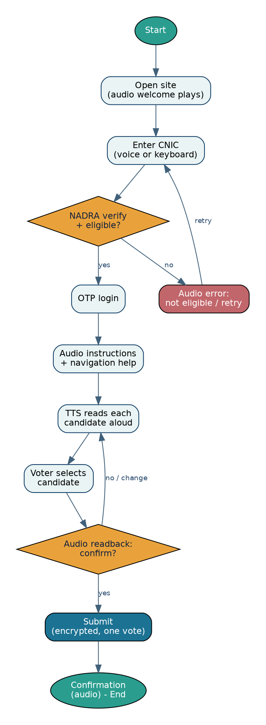
Figure 3: Voter interaction workflow (system flow)
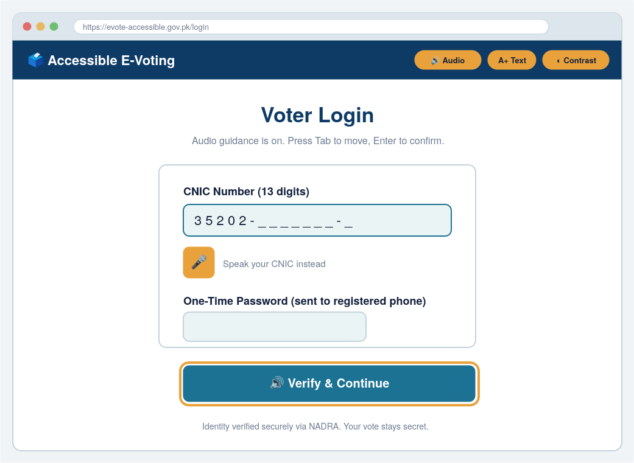
Figure 4: Voter login — CNIC + OTP with audio guidance and voice input
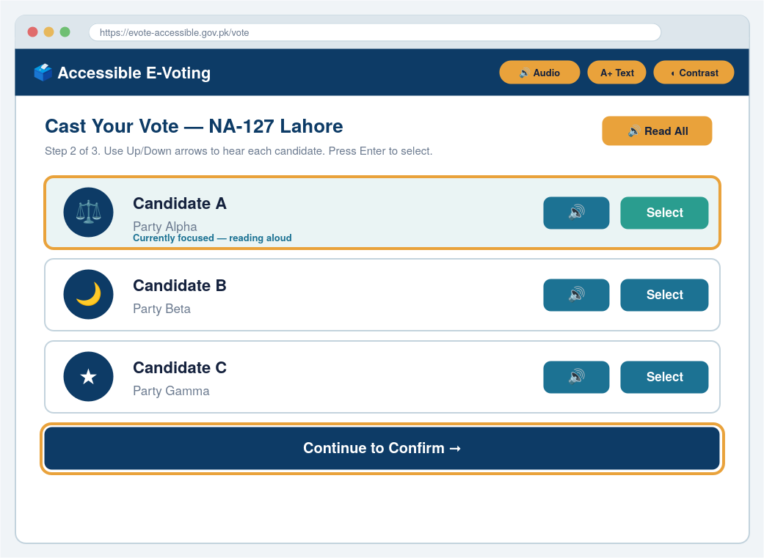
Figure 5: Ballot / cast vote — large high-contrast candidate cards with read-aloud and visible focus
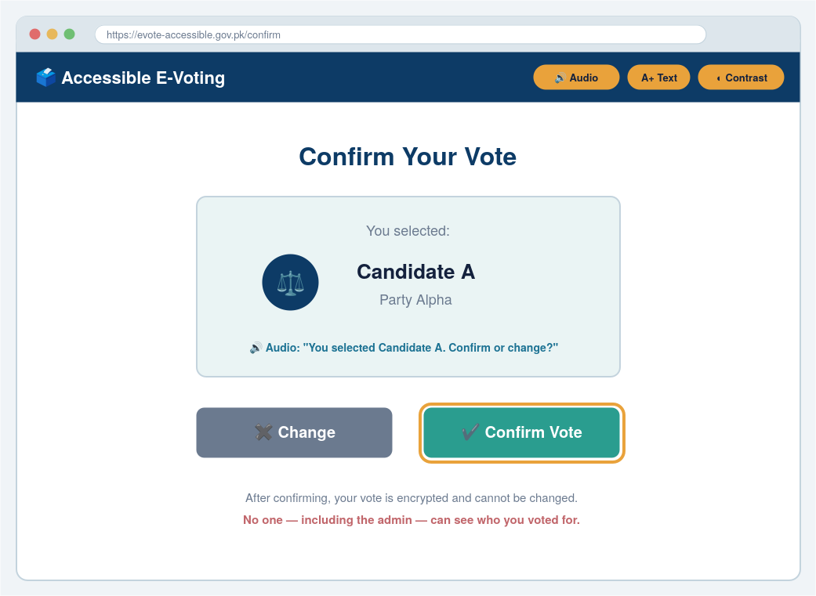
Figure 6: Vote confirmation — audio read-back before the vote is finalised
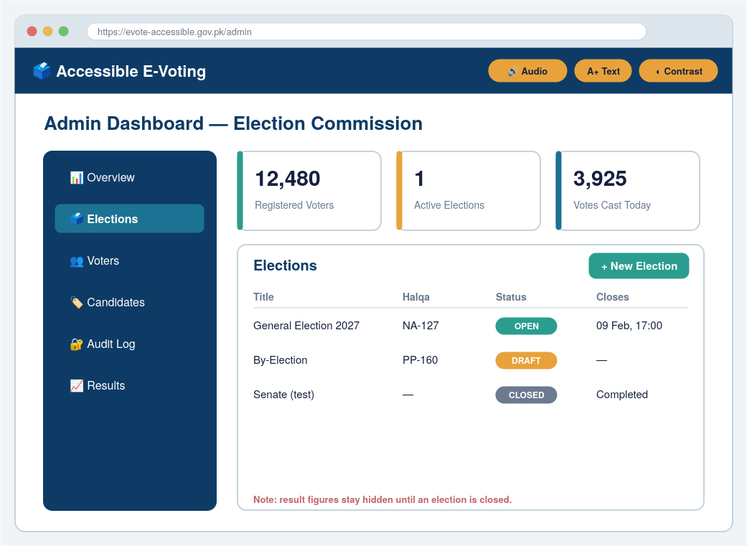
Figure 7: Admin dashboard — manage elections, candidates and voters (Government / ECP)
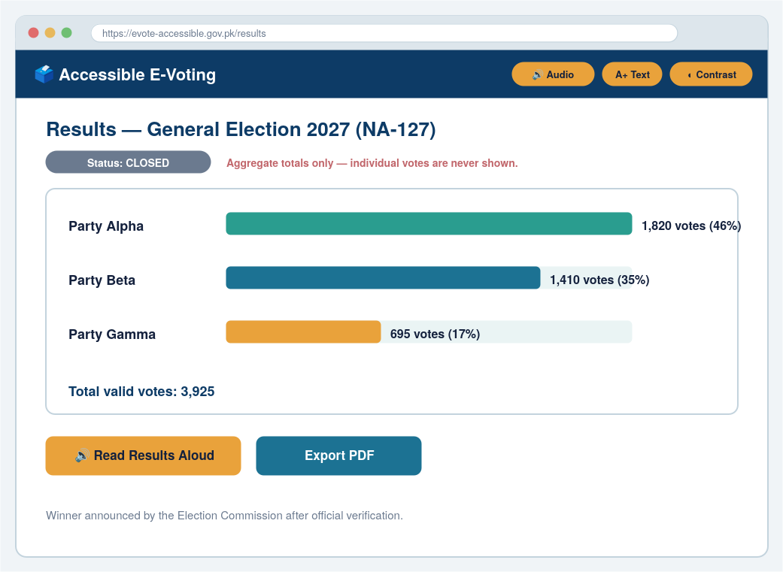
Figure 8: Results — aggregate totals per party, shown only after the election closes

4. Project Planning and Execution using Sprints
The project is executed with Scrum in one-week sprints over a 12-month FYP timeline. This chapter records the supporting tools and the planning and artifacts of Sprint 1.

4.1 Jira
Jira hosts the product backlog and the sprint board. Epics, user stories and sub-tasks from Chapter 3 are entered in Jira, prioritised with MoSCoW and estimated in story points; the sprint board tracks items through To-Do, In-Progress and Done. A CSV export of the backlog accompanies this submission for import into Jira.

4.2 Slack
Slack is the team’s communication channel (replacing informal messaging), with channels for general coordination, stand-ups, and integration notifications from GitHub and Jira.

4.3 GitHub Repository
Source code is version-controlled on GitHub using a feature-branch workflow with pull-request reviews. GitHub Copilot is used for AI-assisted coding. The repository will hold the Django application, tests, and the installation and user guides.

4.4 Sprint 1

4.4.1 Sprint 1 Planning Meeting Minutes
Note: the following minutes are a prepared draft to be confirmed with the supervisor; the date and attendance should be updated to reflect the actual meeting.
Field | Detail
Meeting | Sprint 1 Planning
Date / Time | 19-6-2026 (to be confirmed with supervisor)
Location | Department of Software Engineering, UMT
Attendees | Inayat Ullah, Salar Khan, Uzair Shakir; Supervisor: Dr. Amber Sultan
Sprint length | 6 week
Sprint Goal | Deliver a foundational, audio-accessible vote-casting slice: a verified voter can log in, hear the ballot via TTS, navigate by keyboard, and select a candidate.
Table 8: Sprint 1 planning — meeting overview
Selected backlog items for Sprint 1 (committed):
ID | User Story | Priority | Points | Hours
US-01 | As a voter, I can register with my CNIC so the system knows I am an eligible disabled voter. | Must | 5 | 16
US-03 | As a voter, I log in with CNIC + OTP so my account stays secure. | Must | 5 | 16
US-04 | As the system, I confirm a voter is registered as disabled before allowing a vote. | Must | 3 | 8
US-06 | As a blind voter, every page is read aloud by TTS so I can use the system without sight. | Must | 8 | 24
US-07 | As a blind voter, I can navigate the whole app by keyboard only. | Must | 5 | 16
US-17 | As a voter, I can hear the list of candidates and select one. | Must | 5 | 16
Table 9: Sprint 1 committed backlog items
Sprint 1 commitment: 6 stories, 31 story points (≈ 96 hours). With three members and roughly 30 available hours each in the week (~90 hours), this is an ambitious but achievable foundational sprint; lower-priority items will be moved to Sprint 2 if velocity is lower than planned.
Task distribution among team members:
Member | Role | Sprint 1 focus
Inayat Ullah | Backend Developer | Voter model, registration, CNIC validation, login/OTP, eligibility check (US-01, US-03, US-04).
Salar Khan | AI Integration | TTS read-aloud engine and audio confirmation flow (US-06, US-11 support).
Uzair Shakir | Frontend Developer | Accessible ballot page, keyboard navigation, focus styles, candidate selection (US-07, US-17).
Table 10: Sprint 1 task distribution
Sprint timeline (one week):
Week | Activity
Week 1 | Sprint planning; environment, repo and Jira board setup; data models.
Week 2–3 | Registration, login/OTP and eligibility (backend); ballot page scaffold (frontend).
Week 4 | TTS read-aloud and audio confirmation; keyboard navigation and candidate selection.
Week 5 | Integration and accessibility testing (screen reader + keyboard).
Week 6 | Sprint review and retrospective.
Table 11: Sprint 1 timeline
Identified risks:
Risk | Impact | Mitigation
NADRA CNIC API access unavailable | Blocks real verification | Use a mock verifier in Sprint 1; integrate the real API in Sprint 2 (US-02).
Cross-browser TTS inconsistency | Audio may differ by browser | Target the Web Speech API with a server-side TTS fallback; test on Chrome/Edge.
Ambitious Sprint-1 scope | Spillover to Sprint 2 | Strict MoSCoW prioritisation; defer ‘Should/Could’ items first.
Limited access to blind test users | Weaker usability feedback | Test with screen readers (NVDA) and recruit a user for later sprints.
Table 12: Sprint 1 risks and mitigations

4.4.2 Sprint 1 Backlog
The Sprint 1 backlog breaks the committed stories into their tasks with status, mirroring the Jira sprint board.
Story | Task | Owner | Status
US-01 | Design Voter model (CNIC, disability type, eligibility) | Inayat | To-Do
US-01 | Build registration form (Django) + server-side CNIC validation | Inayat | To-Do
US-03 | OTP generation + SMS stub; login view and sessions | Inayat | To-Do
US-04 | Eligibility check in AuthService | Inayat | To-Do
US-06 | Integrate Web Speech API / TTS engine | Salar | To-Do
US-06 | Add aria-live regions and per-page read-aloud controller | Salar | To-Do
US-11 | Audio read-back of selection before submit | Salar | To-Do
US-07 | Logical tab order, visible focus, skip-to-content | Uzair | To-Do
US-17 | Ballot page with candidate cards + keyboard selection | Uzair | To-Do
Table 13: Sprint 1 backlog (tasks and status)

4.4.3 Sprint 1 Design Class Diagram
The class diagram for the Sprint 1 scope models the core domain (User, Voter, Admin, Election, Candidate, Vote) together with the services exercised in the first sprint (AuthService, CNICVerifier and the AudioService/TTS).
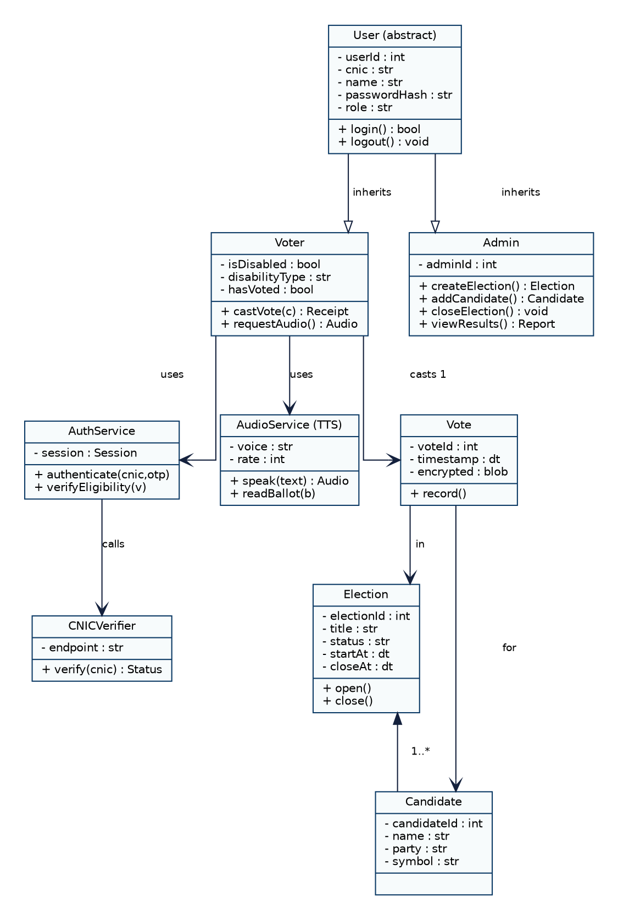
Figure 9: Sprint 1 design class diagram

4.4.4 Sprint 1 Sequence Diagram
The sequence diagram traces the primary Cast-Vote scenario from the blind voter’s perspective: opening the ballot, CNIC/OTP authentication via NADRA, audio reading of candidates, selection with read-back confirmation, and the encrypted, one-vote-enforced submission.
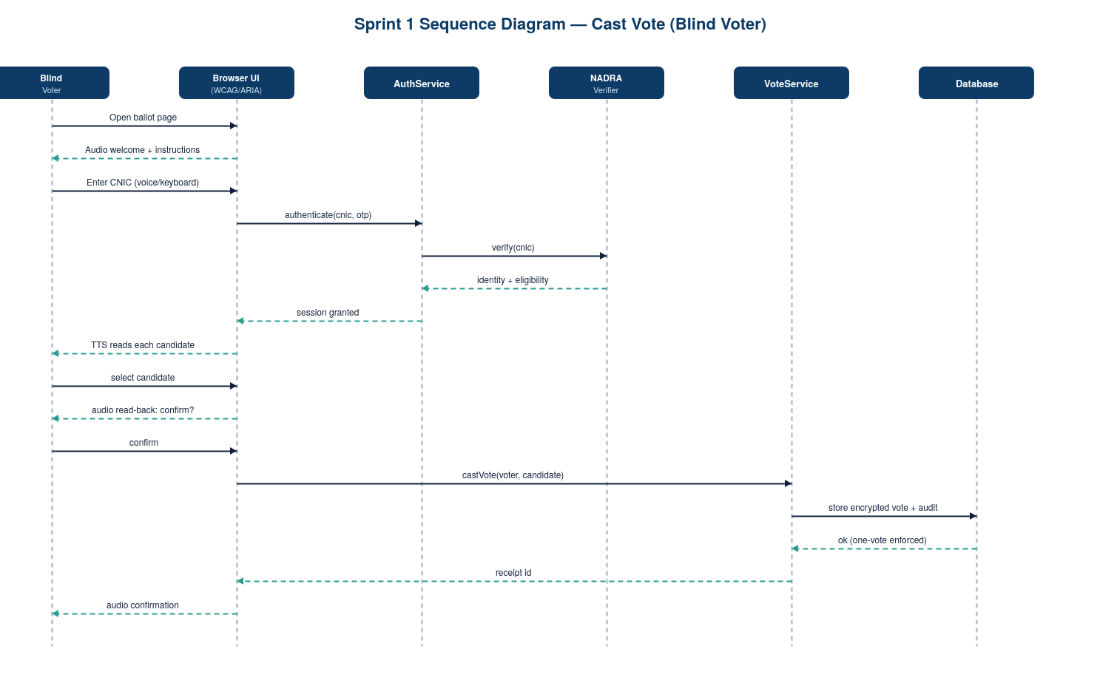
Figure 10: Sprint 1 sequence diagram — Cast Vote

4.4.5 Sprint 1 Decision Table
The decision table specifies the rules that govern whether a vote may be cast, covering identity verification, eligibility, the voting window and the one-vote rule.
Condition | R1 | R2 | R3 | R4 | R5
CNIC verified (NADRA) | T | F | T | T | T
Registered as disabled / eligible | T | — | F | T | T
Election is open | T | — | — | F | T
Voter has not already voted | T | — | — | — | F
Action: allow vote | Yes | No | No | No | No
Audio message | Proceed | Verify failed | Not eligible | Closed | Already voted
Table 14: Decision table for vote-casting eligibility

4.4.6 Sprint 1 Extended Test Cases
TC | Scenario | Steps / Input | Expected Result | Story
TC-01 | Valid voter casts vote | Verified CNIC + OTP; open election; select candidate; confirm | Vote recorded once; audio confirmation; receipt id | US-17/18
TC-02 | Invalid CNIC | Enter CNIC that fails verification | Login refused; audio ‘verification failed’ | US-02/03
TC-03 | Double voting blocked | Voter who already voted attempts again | Blocked; audio ‘already voted’ | US-18
TC-04 | Keyboard-only navigation | Navigate entire ballot using Tab/Arrows/Enter | All controls reachable; visible focus | US-07
TC-05 | Screen-reader reading | Open ballot with NVDA | Each candidate and instruction announced | US-06/08
TC-06 | Read-back before submit | Select candidate | System reads selection and asks to confirm | US-11
TC-07 | Vote secrecy | After voting, attempt to view choice | No record of choice is retrievable | US-21/24
TC-08 | Voting outside window | Attempt to vote before open / after close | Blocked; audio ‘election closed’ | US-15/22
Table 15: Sprint 1 extended test cases

4.4.7 Sprint 1 Review Meeting
Note: a prepared template to be completed at the end of Sprint 1.
Field | Detail
Date | End of Sprint 1 (TBD)
Attendees | Project team; Supervisor: Dr. Amber Sultan
Completed (Done) | To be recorded — stories accepted against their acceptance criteria.
Demonstrated | Login + audio-read ballot + keyboard selection + read-back confirmation.
Incomplete / carried over | To be recorded — any spillover moved to Sprint 2.
Stakeholder feedback | To be recorded from the supervisor’s review.
Table 16: Sprint 1 review meeting

4.4.8 Sprint 1 Retrospective Meeting
Note: a prepared template to be completed at the end of Sprint 1.
What went well | What to improve | Actions for next sprint
(to be filled) | (to be filled) | Integrate real NADRA verification (US-02)
(to be filled) | (to be filled) | Add high-contrast / text-size options (US-09)
(to be filled) | (to be filled) | Implement vote encryption (US-19) and secrecy checks
Table 17: Sprint 1 retrospective

5. System Architecture
To be completed in subsequent phases: system context (C4) and container diagrams, component diagrams, code diagrams, ERD and data dictionary.

6. Implementation Details
To be completed: development and deployment setup, algorithms, and constraints (assumptions, system constraints, restrictions, limitations).

7. Project Monitoring, Control and Traceability
To be completed: traceability matrices (requirements vs prototype, requirements vs test cases).

8. Results / Output / Statistics
To be completed: % completion, % accuracy, % correctness.

9. Conclusion
To be completed at the end of the project.

10. Future Work
- Sign-language recognition and lip-reading support for deaf users.
- Biometric / facial-recognition authentication as an optional second factor.
- Multilingual audio (Urdu and regional languages).
- Pilot deployment and formal accessibility audit with blind users.

11. Bibliography
See the References in Section 2.9; a consolidated bibliography will be compiled in the final report.

12. Appendix
To be completed: glossary of terms and pre-requisites.

